* Short summary: Offers last mile mobility firms like Uber a way to reach NetZero by incentivizing drivers to adopt sustainable vehicles with our reward app ZenVolt
* Full description:

ZenVolt is a cutting-edge application built on the VeChain blockchain, designed to transform the gig delivery industry into a more sustainable and efficient sector. Addressing the growing concerns about environmental impact and the inefficiency in the gig economy, ZenVolt offers a robust solution by incentivizing sustainable delivery practices among gig workers.

The app uniquely positions itself as a sustainability partner for major gig economy companies like Swiggy, Uber, and Deliveroo, helping them achieve their net-zero goals. Instead of these companies investing in traditional carbon offsets, ZenVolt offers a more proactive and integrative approach. By collaborating with ZenVolt, they channel their investments directly into sustainable practices within their delivery operations.

ZenVolt leverages advanced technology to track, verify, and ensure the trustworthiness of delivery data. This is achieved through the integration of EV GPS tracking, connection with various gig apps, and monitoring delivery speeds. These metrics not only ensure efficient and eco-friendly deliveries but also provide transparent and verifiable data through the VeChain blockchain.

By using blockchain technology, ZenVolt creates an immutable record of each delivery's environmental footprint, ensuring accuracy and reliability in reporting sustainable practices. Gig workers earn rewards in the form of tokens for their sustainable actions, which can be used for various benefits, enhancing their engagement and commitment to eco-friendly practices.

ZenVolt is more than just an app; it's a sustainable movement in the gig economy, empowering workers and companies alike to be active participants in the fight against climate change, while improving operational efficiency and transparency.

* Clearly highlight the main USP (unique selling proposition) in 2-3 easy to remember statements

ZenVolt's main USPs are:

1. Sustainable Gig Economy Revolution: ZenVolt transforms the gig delivery sector by integrating sustainability directly into everyday operations, allowing companies like Swiggy, Uber, and Deliveroo to meet their net-zero goals more effectively than traditional carbon offsets.
2. Advanced Technology for Trustworthy Tracking: Utilizing the power of VeChain's blockchain alongside EV GPS tracking and gig app connectivity, ZenVolt offers unparalleled transparency and accuracy in tracking and verifying each sustainable delivery action.
3. Incentivizing Green Practices: By rewarding gig workers with tokens for eco-friendly deliveries, ZenVolt not only promotes environmental responsibility but also empowers workers financially, creating a win-win for the planet and the gig economy workforce.

* Include a brief competitive analysis (including why past similar projects failed and how you aim to learn from their failures) and estimate the entire market and addressable market

eTukTuk – creating its own cryptocurrency to accompany its EV-as-a-service model with a play-to-earn taxi game (India)​

* Include an overview of the tokenomics (e.g. X-to-earn / incentives)

ZenVolt's tokenomics is built on a robust 'X-to-Earn' model, incentivizing sustainable behaviors in the gig economy. Here's an overview:

Earning Tokens for Sustainable Actions: Gig workers earn tokens for each delivery made using sustainable practices, such as utilizing electric vehicles, optimizing delivery routes, or reducing carbon emissions. This direct reward system encourages continuous engagement in eco-friendly activities.

Redemption and Utility: Earned tokens can be redeemed for various benefits, enhancing the gig workers' experience and tools. This includes equipment upgrades, maintenance services, or access to exclusive features within the ZenVolt app. Additionally, tokens might be exchanged for cryptocurrencies or other digital assets, providing financial incentives to the workers.

Integration with Gig Economy Platforms: The tokens integrate seamlessly with partner platforms like Swiggy, Uber, and Deliveroo, allowing these companies to contribute to sustainability without traditional carbon offsets. This partnership creates a closed-loop ecosystem where sustainability is both rewarded and reinvested into the system.

* Show how the token is linked with the real world (Phygitals or NFTs)

ZenVolt's token system innovatively links digital incentives with real-world benefits, merging the concept of physical and digital realms (phygitals) and Non-Fungible Tokens (NFTs). Here’s how it works:

Token Redemption for Physical Goods and Services: Earned tokens can be redeemed for real-world items and services essential for gig workers, such as maintenance services for electric vehicles, equipment upgrades, or even sustainable lifestyle products. This tangible reward system encourages consistent and meaningful participation in eco-friendly practices.

NFTs for Unique Assets and Experiences: ZenVolt also integrates NFTs, which represent unique digital or physical assets. For example, a gig worker could receive a limited-edition NFT for achieving a sustainability milestone, which can be traded or redeemed. These NFTs could be linked to special privileges, like exclusive access to high-demand routes or discounts on eco-friendly products.

Phygitals for Enhanced Engagement: The concept of phygitals is employed to provide a seamless blend of physical and digital experiences. For instance, completing a certain number of sustainable deliveries could unlock a digital badge that comes with a physical counterpart, like branded sustainable gear, enhancing the sense of achievement and brand loyalty.

* Include an estimation of the amount of pre-seed money you would need to get to MVP

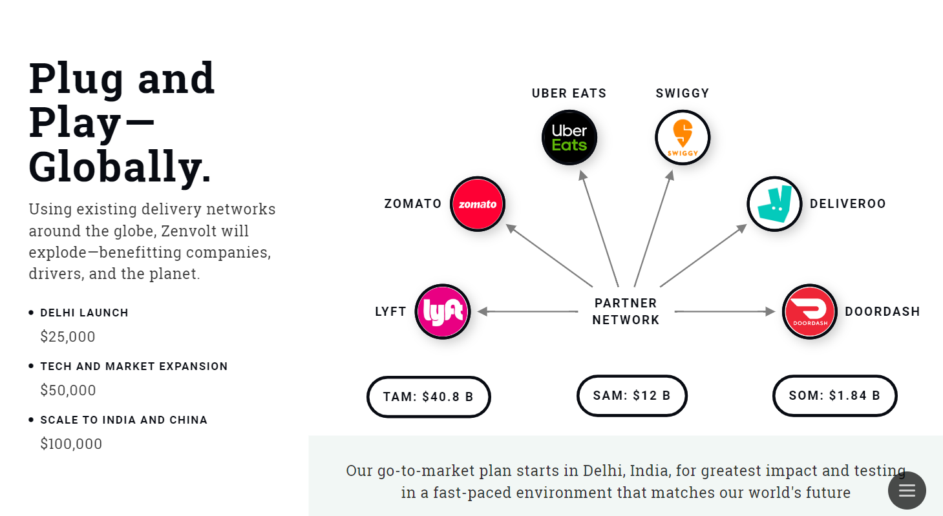

* Define a go-to-market / roll out plan (to promote this venture and to acquire first 5,000 users / clients)

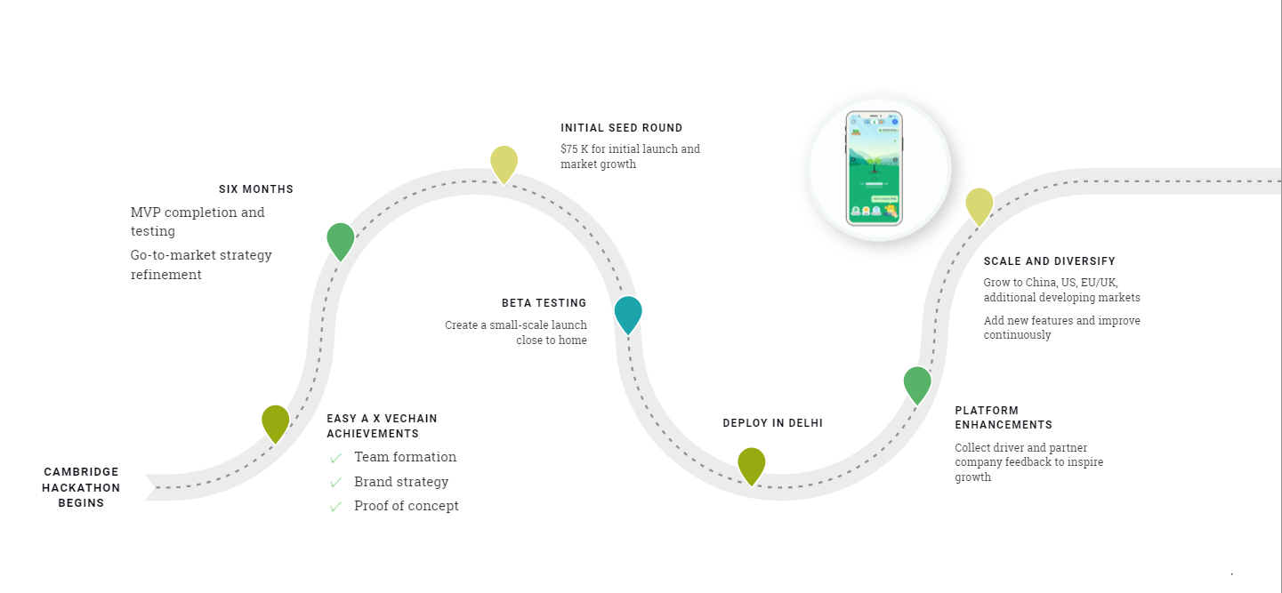

* Include a team slide, describing your team and backgrounds



* Include a technical description (what SDKs were used, and what features of vechain made this uniquely possible)

Blockchain: ZenVolt leverages the comprehensive features offered by VeChain. This includes VeChain's Thor blockchain's features like high-speed transactions and low gas costs, which is crucial for the real-time processing of rewards and data tracking in the gig economy. The VeChain blockchain's unique multi-party payment (MPP) and multi-task transaction (MTT) features enable ZenVolt to efficiently handle complex transactions. These include distributing rewards to gig workers and facilitating transactions between multiple stakeholders like delivery companies and sustainability initiatives.

Smart Contract: We used Remix IDE to develop the smart contract that allowed seamless connection with gig workers' EV GPS tracking systems, gig app integrations, and delivery speed monitoring systems.

Front End: We used JavaScript and React JS to create a common code base for iOS and Android apps, resulting in code reuse.

Infrastructure: In future, the entire solution will be hosted on cloud to reduce operation costs and emissions.

* Include a link to the Canva slides used in the presentation (make sure you include a slide on your team, problem, solution etc). You must use Canva for your presentation.

https://www.canva.com/design/DAF_w816y9c/oRw5VQ9fwzC5jP8fzBue1w/edit?utm_content=DAF_w816y9c&utm_campaign=designshare&utm_medium=link2&utm_source=sharebutton